# **Part A**

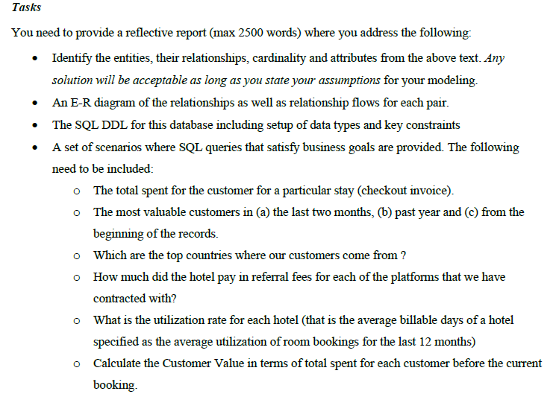

# **Part B**

The Data Provided looks like:

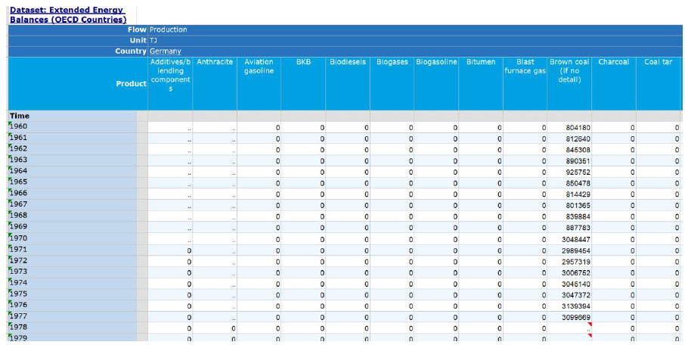

Your goal is to use R to provide a dataset that conforms with the following structure like this:

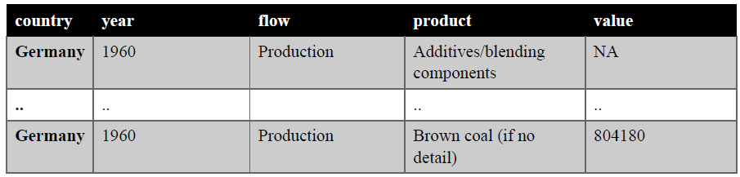country year flow product value Germany 1960 Production Additives/blending components NA

The combination of country, year and flow and product should be unique, suggesting that there is only one particular value for that particular combination of the other 3 columns. Provide total number of records on the dataset and the total number of records for each product across countries across years.

# **Part C**

The UK Food Standards Agency runs the food hygiene rating scheme which aims to evaluate the standards of food hygiene found on the date of the inspection in a restaurant serving food by the local authority. The food hygiene rating sticker looks like this:

The UK government provides an open API in either JSON or XML to download the data and make them available under the following URL:

https://www.food.gov.uk/uk-food-hygiene-rating-data-api

Your job is to write an R script to fetch the ratings dataset from the government website and store it in a format that will enable further analysis. The resulting data frame should capture all XML defined fields from the website. You need to document and articulate every stage in your code and explain your steps clearly.

# **Part D**

Using the food hygiene data, create a Shiny dashboard where you depict a navigation scenario for the ratings. You are free to select the scenario that you think that is more appropriate. Your solution needs to include the following:

• A map depicting the locations of the rated companies using the geocode information

• A graphical representation of the rating values as obtained from the parsing of the XML document.

Additional representations and visualizations will be considered as a plus but will not exclude the attenuation of a full mark.